ABC Payroll Program Project Plan
SDEV268, Winter 2025
Group 3

Contents
- Introduction
- Developmental Goals
- Key Features (number of screens, menus, database choice, etc.)
- Screen Layouts
- Database and Algorithms (and rationale behind choices for database and what algorithms are being used and why)
- Work Breakdown (roadmap of phases of development for the next 8 weeks
- UML Diagrams
- Programming Standards and Security
- Summary

Introduction
The ABC Company Payroll Project is a comprehensive software development initiative aimed at designing and implementing a secure, scalable, and fully functional payroll management system using the Python programming language. This application will serve as a critical tool for automating payroll processes, including the collection of employee work hours, calculation of gross and net pay, application of pre-tax deductions, and generation of payroll reports. The system will support both salaried and hourly employees, incorporate validation mechanisms to ensure data integrity, and enforce security protocols through role-based access and credential management. This project plan outlines the strategic approach to development, including system requirements, user interface design, database structure, algorithm selection, and testing procedures. It also defines the roles of system actors, documentation standards, and a week-by-week breakdown of deliverables. The ultimate goal is to produce a robust, user-friendly application that not only meets the specified requirements but also showcases the developer’s technical proficiency and readiness for real-world software engineering challenges.

Developmental Goals
The developmental goals for the ABC Company Payroll Project center on building a secure, scalable, and fully functional Python-based payroll application that meets all specified business and technical requirements. This includes implementing accurate payroll calculations for both hourly and salaried employees, integrating pre-tax deductions and employer contributions, and designing intuitive user interfaces for both admin and employee roles. The project aims to reinforce key software development competencies such as algorithm design, data validation, database integration, and secure authentication workflows. Additionally, the application will serve as a portfolio-grade deliverable that demonstrates proficiency in object-oriented programming, documentation standards, and user-centered design. By completing this project, the developer will deepen their understanding of payroll logic, modular architecture, algorithm selection/use, and end-to-end application lifecycle management.

Key Features

The ABC Company Payroll Project is designed to deliver a secure, fully functional Python-based payroll system that supports both administrative and employee roles. At its core, the application must include a mandatory login system with role-based access, where employees receive automated credentials and the admin uses a predefined secure login. Once authenticated, users will access tailored features based on their role. Admins must be able to manage employee records, calculate payroll, and generate reports, while employees should be able to enter hours worked, request PTO, and view paycheck details. The system must handle both salaried and hourly pay structures, with logic to calculate overtime and time-and-a-half for qualifying hours. Payroll calculations must incorporate pre-tax deductions and apply accurate tax rates for both employee and employer contributions. Specifically, the application must support:
- Medical deductions: $50 for single coverage, $100 for family
- Dependent stipends: $45 per dependent
- Tax rates (Employee and Employer):
  - State tax: 3.15%
  - Federal tax: 7.65%
  - Social Security: 6.2%
  - Medicare: 1.45%
All deductions must be applied on a pre-tax basis, and the system should lock time entries once payroll is processed to prevent retroactive changes. Validation logic must be in place to catch anomalies such as excessive work hours or missing required fields. The application should include a structured database with at least twelve fabricated employee profiles for testing, and support data manipulation through arrays or lists. Additional features include:
- Admin tools: Add/edit/delete employees and their information, search personal/pay info, view application info, edit timecards of employees
- Employee tools: Daily time entry, PTO submission, timecard modification, paycheck generation
- Reporting tools: HR sign-off, printable payroll files, saveable file format

Screen Layouts
* These layouts are subject to change and serve as a reference point for core functionalities and requirements
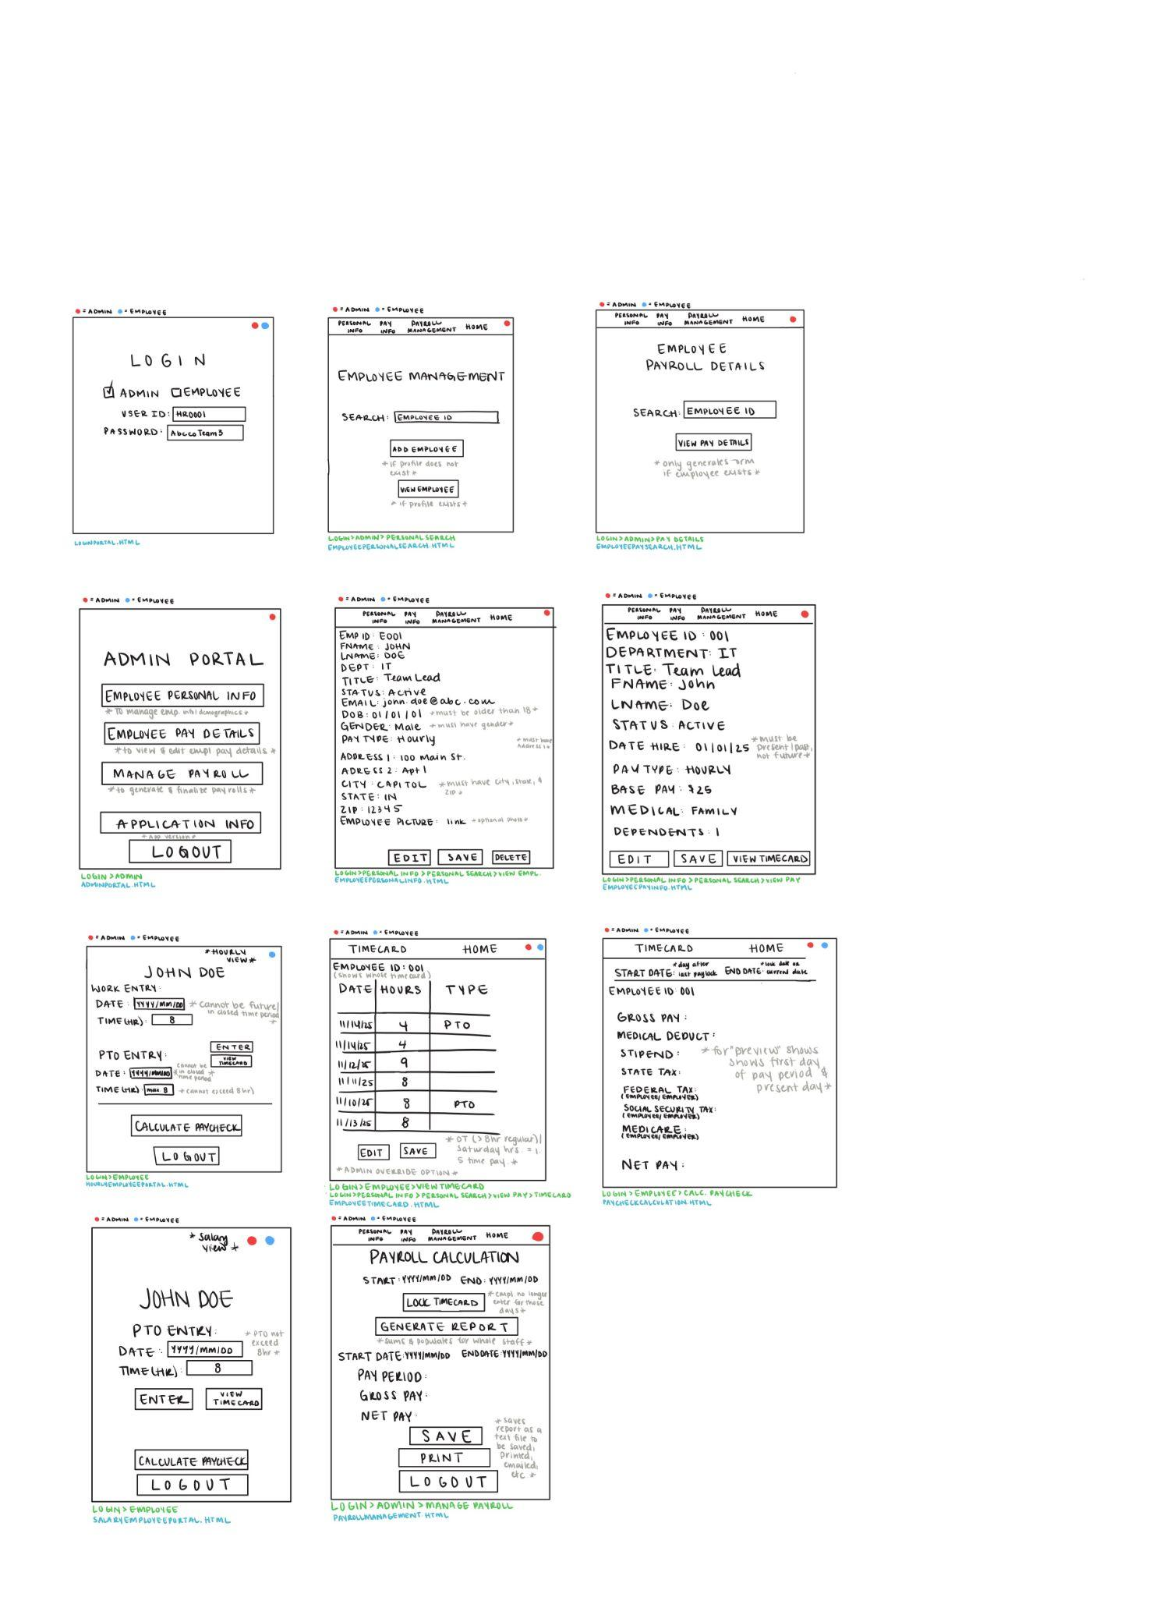
`

Database and Algorithms

Database Choice and Rationale
For this payroll application, we chose SQLite as the database solution due to its simplicity, portability, and seamless integration with Python. SQLite is a lightweight, serverless database that stores data in a single file, making it ideal for small to medium-sized applications like this one. It eliminates the need for complex setup or external dependencies, allowing for faster development and easier testing. Since the project requires managing structured employee data, including demographics, salary details, and time entries, SQLite provides robust support for relational tables and SQL queries while remaining easy to maintain. Its compatibility with Python’s built-in sqlite3 module also ensures smooth data handling and efficient CRUD operations throughout the application. Overall, SQLite offers the right balance of functionality and convenience for a standalone, locally hosted payroll system.

Database Structure(s)

Departments Table

CREATE TABLE departments (
department_id INTEGER PRIMARY KEY AUTOINCREMENT,
department_name TEXT NOT NULL UNIQUE,
created_date TEXT NOT NULL DEFAULT (datetime('now', 'localtime'))
);

Job Titles Table

CREATE TABLE job_titles (
job_title_id INTEGER PRIMARY KEY AUTOINCREMENT,
title_name TEXT NOT NULL UNIQUE,
created_date TEXT NOT NULL DEFAULT (datetime('now', 'localtime'))
);

Employees Table

CREATE TABLE employees (
employee_id TEXT PRIMARY KEY,
first_name TEXT NOT NULL,
last_name TEXT NOT NULL,
surname TEXT,
date_of_birth TEXT NOT NULL,
gender TEXT NOT NULL CHECK(gender IN ('Male', 'Female')),
email TEXT NOT NULL UNIQUE,
phone_num TEXT,
address_line1 TEXT NOT NULL,
address_line2 TEXT,
city TEXT NOT NULL,
state TEXT NOT NULL,
zip_code TEXT NOT NULL,
has_picture INTEGER NOT NULL DEFAULT 0,
picture_filename TEXT,
status TEXT NOT NULL DEFAULT 'Active' CHECK(status IN ('Active', 'Terminated')),
date_hired TEXT NOT NULL,
department_name TEXT NOT NULL,
job_title_name TEXT NOT NULL,
created_date TEXT NOT NULL DEFAULT (datetime('now', 'localtime')),
modified_date TEXT NOT NULL DEFAULT (datetime('now', 'localtime')),
FOREIGN KEY (department_name) REFERENCES departments(department_name),
FOREIGN KEY (job_title_name) REFERENCES job_titles(title_name)
);

Compensation Table

CREATE TABLE compensation (
compensation_id INTEGER PRIMARY KEY AUTOINCREMENT,
employee_id TEXT NOT NULL UNIQUE,
salary_type TEXT NOT NULL CHECK(salary_type IN ('Salary', 'Hourly')),
base_salary REAL,
hourly_rate REAL,
medical_type TEXT NOT NULL CHECK(medical_type IN ('Single', 'Family')),
num_dependents INTEGER NOT NULL DEFAULT 0 CHECK(num_dependents >= 0),
effective_date TEXT NOT NULL,
created_date TEXT NOT NULL DEFAULT (datetime('now', 'localtime')),
modified_date TEXT NOT NULL DEFAULT (datetime('now', 'localtime')),
FOREIGN KEY (employee_id) REFERENCES employees(employee_id),
CHECK (
(salary_type = 'Salary' AND base_salary IS NOT NULL AND base_salary > 0 AND hourly_rate IS NULL) OR
(salary_type = 'Hourly' AND hourly_rate IS NOT NULL AND hourly_rate > 0 AND base_salary IS NULL)
)
);

Users Table

CREATE TABLE users (
user_id INTEGER PRIMARY KEY AUTOINCREMENT,
username TEXT NOT NULL UNIQUE,
password_hash TEXT NOT NULL,
user_type TEXT NOT NULL CHECK(user_type IN ('Admin', 'Employee')),
employee_id TEXT,
is_active INTEGER NOT NULL DEFAULT 1,
failed_login_attempts INTEGER NOT NULL DEFAULT 0,
locked_until TEXT,
last_login TEXT,
created_date TEXT NOT NULL DEFAULT (datetime('now', 'localtime')),
FOREIGN KEY (employee_id) REFERENCES employees(employee_id)
);

Payroll Periods Table

CREATE TABLE payroll_periods (
payroll_id INTEGER PRIMARY KEY AUTOINCREMENT,
period_start_date TEXT NOT NULL,
period_end_date TEXT NOT NULL,
processed_date TEXT,
is_locked INTEGER NOT NULL DEFAULT 0,
processed_by TEXT,
created_date TEXT NOT NULL DEFAULT (datetime('now', 'localtime')),
UNIQUE(period_start_date, period_end_date),
CHECK (date(period_end_date) >= date(period_start_date))
);

TIME ENTRIES (Daily records for each employee)

CREATE TABLE time_entries (
time_entry_id INTEGER PRIMARY KEY AUTOINCREMENT,
employee_id TEXT NOT NULL,
payroll_id INTEGER,
entry_date TEXT NOT NULL,
day_of_week TEXT NOT NULL CHECK(day_of_week IN ('Monday', 'Tuesday', 'Wednesday', 'Thursday', 'Friday', 'Saturday', 'Sunday')),
hours_worked REAL NOT NULL DEFAULT 0,
pto_hours REAL NOT NULL DEFAULT 0,
is_saturday INTEGER NOT NULL DEFAULT 0,
notes TEXT,
created_date TEXT NOT NULL DEFAULT (datetime('now', 'localtime')),
modified_date TEXT NOT NULL DEFAULT (datetime('now', 'localtime')),
FOREIGN KEY (employee_id) REFERENCES employees(employee_id),
FOREIGN KEY (payroll_id) REFERENCES payroll_periods(payroll_id),
UNIQUE(employee_id, entry_date),
CHECK (hours_worked >= 0 AND hours_worked <= 24),
CHECK (pto_hours >= 0 AND pto_hours <= 8),
CHECK (pto_hours + hours_worked <= 24)
);

PTO BALANCES (Track accumulated PTO)

CREATE TABLE pto_balances (
pto_balance_id INTEGER PRIMARY KEY AUTOINCREMENT,
employee_id TEXT NOT NULL UNIQUE,
total_accrued REAL NOT NULL DEFAULT 0,
total_used REAL NOT NULL DEFAULT 0,
balance REAL NOT NULL DEFAULT 0,
last_updated TEXT NOT NULL DEFAULT (datetime('now', 'localtime')),
FOREIGN KEY (employee_id) REFERENCES employees(employee_id),
CHECK (balance >= 0),
CHECK (balance <= 80)
);

Payroll Details Table

CREATE TABLE payroll_details (
payroll_detail_id INTEGER PRIMARY KEY AUTOINCREMENT,
payroll_id INTEGER NOT NULL,
employee_id TEXT NOT NULL,

regular_hours REAL NOT NULL DEFAULT 0,
overtime_hours REAL NOT NULL DEFAULT 0,
saturday_hours REAL NOT NULL DEFAULT 0,
pto_hours REAL NOT NULL DEFAULT 0,
total_hours REAL NOT NULL DEFAULT 0,

base_pay REAL NOT NULL DEFAULT 0,
overtime_pay REAL NOT NULL DEFAULT 0,
saturday_pay REAL NOT NULL DEFAULT 0,
gross_pay REAL NOT NULL DEFAULT 0,

medical_deduction REAL NOT NULL DEFAULT 0,
dependent_stipend REAL NOT NULL DEFAULT 0,

taxable_income REAL NOT NULL DEFAULT 0,

state_tax REAL NOT NULL DEFAULT 0,
federal_tax_employee REAL NOT NULL DEFAULT 0,
social_security_employee REAL NOT NULL DEFAULT 0,
medicare_employee REAL NOT NULL DEFAULT 0,
total_employee_taxes REAL NOT NULL DEFAULT 0,

net_pay REAL NOT NULL DEFAULT 0,

federal_tax_employer REAL NOT NULL DEFAULT 0,
social_security_employer REAL NOT NULL DEFAULT 0,
medicare_employer REAL NOT NULL DEFAULT 0,
total_employer_taxes REAL NOT NULL DEFAULT 0,

calculated_date TEXT NOT NULL DEFAULT (datetime('now', 'localtime')),

FOREIGN KEY (payroll_id) REFERENCES payroll_periods(payroll_id),
FOREIGN KEY (employee_id) REFERENCES employees(employee_id),
UNIQUE(payroll_id, employee_id)
);

Algorithms Used and Rationale
The payroll application will employ a series of deterministic algorithms to calculate employee compensation, apply pre-tax deductions, and compute both employee and employer tax obligations. Core algorithms include conditional logic for calculating gross pay based on salary type (hourly vs. salaried), overtime computation for hourly employees exceeding 8 hours per day or working on Saturdays, and tiered validation algorithms to ensure data integrity (e.g., age ≥ 18, hours ≤ 40/week). Arithmetic algorithms will be used to apply fixed-rate deductions for medical coverage and dependent stipends, followed by tax computation algorithms for state (3.15%), federal (7.65%), Social Security (6.2%), and Medicare (1.45%) contributions. Additional logic will handle net pay calculation, payroll locking, and report generation. These algorithms will be modularized and documented to support maintainability and future enhancements.
- Conditional logic: salary vs hourly, PTO vs hours worked
- Validation algorithms: age check, unusual hours, required fields
- Arithmetic formulas: gross pay, taxable income, net pay
- Overtime logic: time-and-a-half for >8 hrs/day and Saturdays
- Tax computation: applying fixed percentages to taxable income
- Data handling: insertion, deletion, and lookup using lists/arrays
- Security logic: credential generation and role-based access control

Work Breakdown
Over the course of 8 weeks, the project will progress from planning and design to development, testing, and final documentation. Week 1 focuses on requirements gathering, UML diagrams, and database planning. Week 2 moves into UI wireframing and setting up the GitHub repository. Weeks 3 and 4 are dedicated to building core features like login, employee management, and payroll logic. Week 5 introduces time entry and PTO functionality, while Week 6 focuses on payroll calculations, tax logic, and report generation. Week 7 is reserved for structured testing, validation, and security implementation. Finally, Week 8 wraps up with final documentation, user guides, and preparing the GitHub repository for submission.

Week | Focus Area | Key Tasks & Deliverables
Week 1 | Planning & UML Design | - Analyze project requirements and grading rubric  - Identify actors (Admin, Employee)  - Create UML use case and class diagrams  - Draft project plan and 8-week breakdown  - Design initial database schema (SQLite)
Week 2 | UI Wireframes & GitHub Setup | - Sketch wireframes for Login, Dashboard, Employee, Salary, and Time Entry screens  - Set up GitHub repo with folder structure and README  - Create documentation shell (project-plan.md, user-guide.md, security.md)
Week 3 | Login & Security Features | - Build login screen with role-based access  - Implement credential validation and user type selection  - Auto-generate employee credentials (email + DOB)  - Add admin login (HR0001 + secure password)  - Document security protocols
Week 4 | Employee & Salary Screens | - Build employee screen (Admin only)  - Add validations: age ≥ 18, email format, status, gender, etc.  - Enable add/edit/delete/search functionality  - Build salary screen with medical, dependents, and salary info  - Link employee and address tables
Week 5 | Time Entry & PTO Logic | - Build time entry screen (Employee view)  - Add PTO logic for salaried employees  - Add daily hour entry and overtime logic for hourly employees  - Lock entries post-payroll  - Validate unusual entries (e.g., 80+ hours)
Week 6 | Payroll Calculation & Reporting | - Implement payroll logic: gross/net pay  - Apply tax rules (IN 3.15%, Fed 7.65%, SS 6.2%, Medicare 1.45%)  - Calculate medical and dependent deductions  - Generate HR sign-off report and printable payroll file
Week 7 | Testing & Validation | - Create initial testing log and checklist  - Validate all inputs and edge cases  - Add screenshots of passed/failed tests  - Verify accuracy of payroll calculations  - Document test results in final-testing-log.md
Week 8 | Finalization & Submission | - Finalize user documentation and testing logs  - Upload all files to GitHub (code, docs, data)  - Verify repo structure and access  - Submit GitHub link for grading  - Review checklist against grading rubric

UML Diagrams

Use Case Diagram
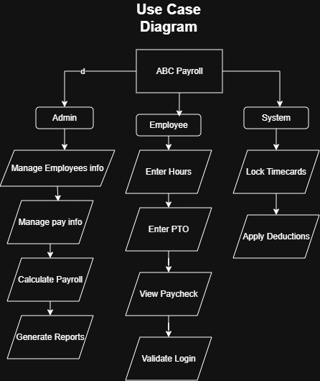

Sequence Diagram
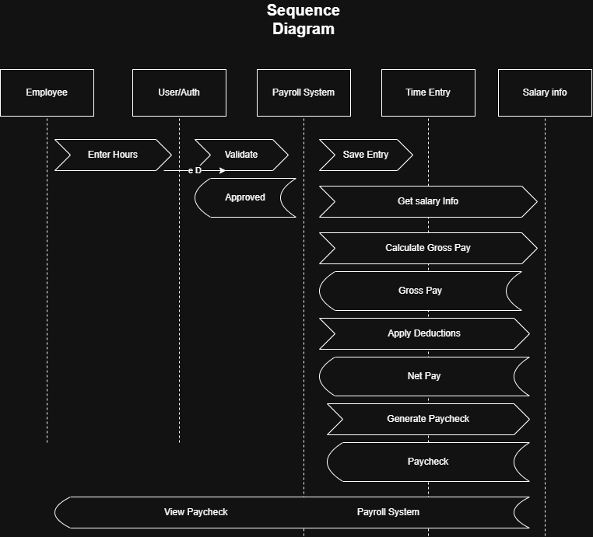

Activity Diagram
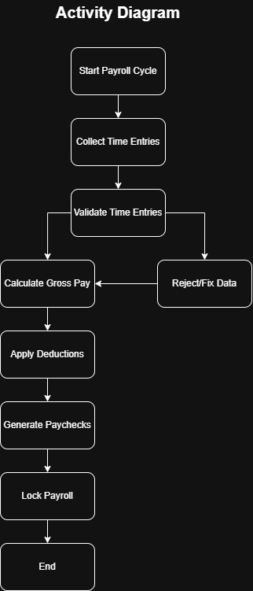

State Diagram
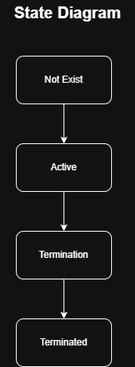

Class Diagram
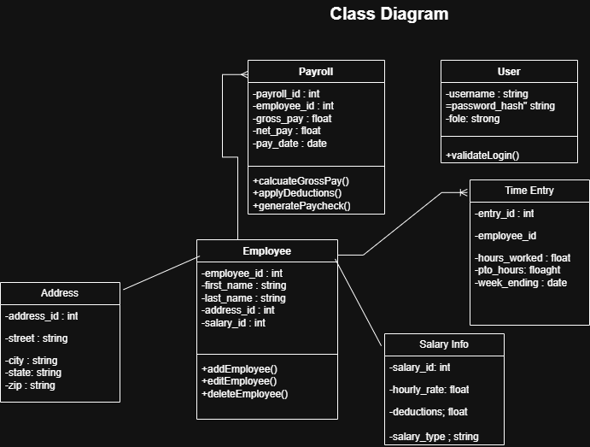

Programming Standards and Security
Throughout the development of the ABC Company Payroll Project, we will adhere to established programming best practices to ensure the application is reliable, maintainable, and secure. This includes writing modular, well-documented code that follows consistent naming conventions and avoids common anti-patterns such as hardcoding values, excessive nesting, and duplicated logic. We will prioritize readability and reusability by implementing clear function boundaries, using meaningful variable names, and applying object-oriented principles where appropriate. Secure coding practices will be enforced across all modules, including input validation to prevent injection attacks, encrypted password storage, and role-based access control to protect sensitive employee data. We will also avoid exposing internal logic or error messages to end users, and ensure that all authentication workflows are handled securely. By following these standards, the application will not only meet functional requirements but also demonstrate a disciplined approach to software engineering.

Summary
The ABC Company Payroll Project is an 8‑week software development initiative to design and implement a secure, scalable, and fully functional payroll management system in Python. The application will automate payroll processes for both salaried and hourly employees, incorporating overtime rules, PTO logic, pre‑tax deductions, and accurate tax calculations. Key features include role‑based login, employee and admin dashboards, structured SQLite database integration, and reporting tools for HR sign‑off and payroll file generation.
Development follows a structured roadmap: requirements analysis and UML design, UI wireframing, core feature implementation (login, employee management, salary and time entry), payroll logic and reporting, followed by testing, validation, and final documentation. Algorithms are modularized to handle gross/net pay, deductions, tax computations, and security protocols. Programming standards emphasize modularity, readability, and secure coding practices, including credential management and input validation.
The project demonstrates technical proficiency in database design, algorithm development, and secure application workflows, while producing a portfolio‑grade deliverable that is user‑friendly, maintainable, and aligned with real‑world payroll requirements.

